**Battleship Game UI Initial Design and Review Feedback**

Pudota, Arpitha

La Roche University

ISTG6010-2025: OBJECT ORIENTED SYSTEMS

Instructor: Dustin Updyke,MS

April 2, 2025

**Design Phase**

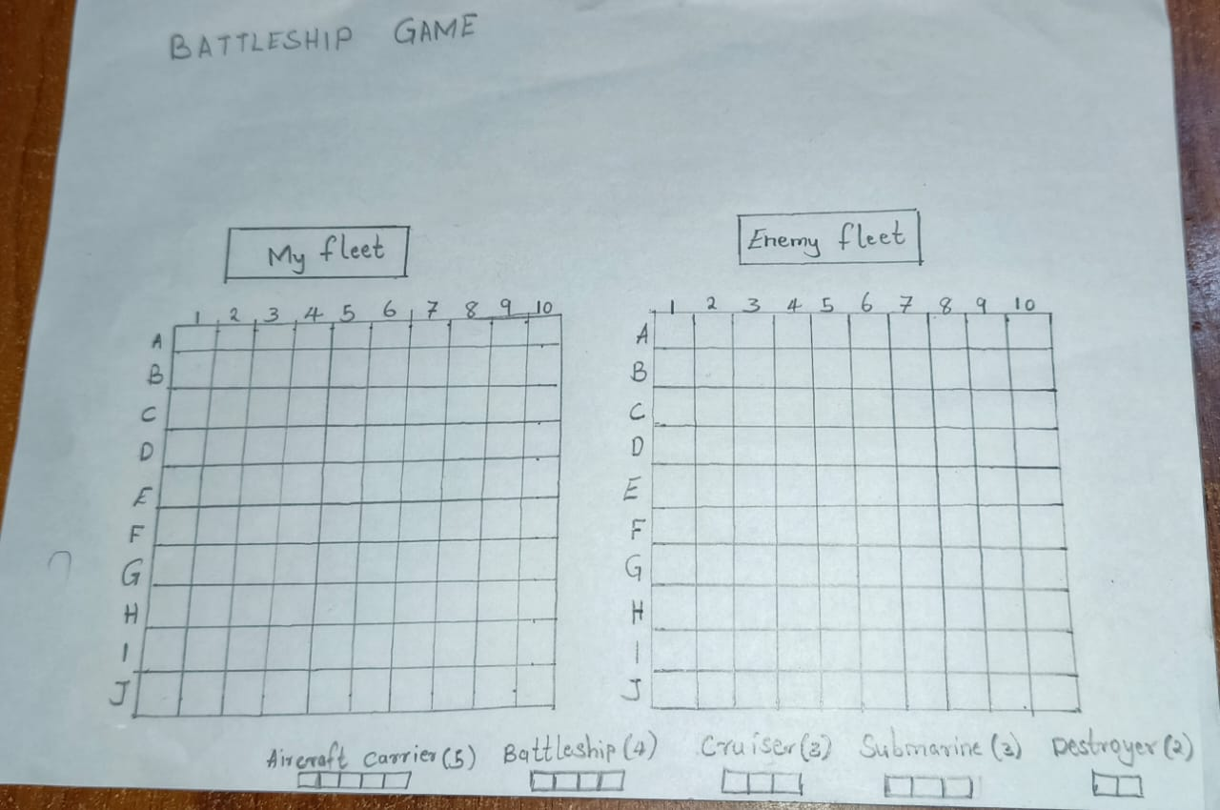

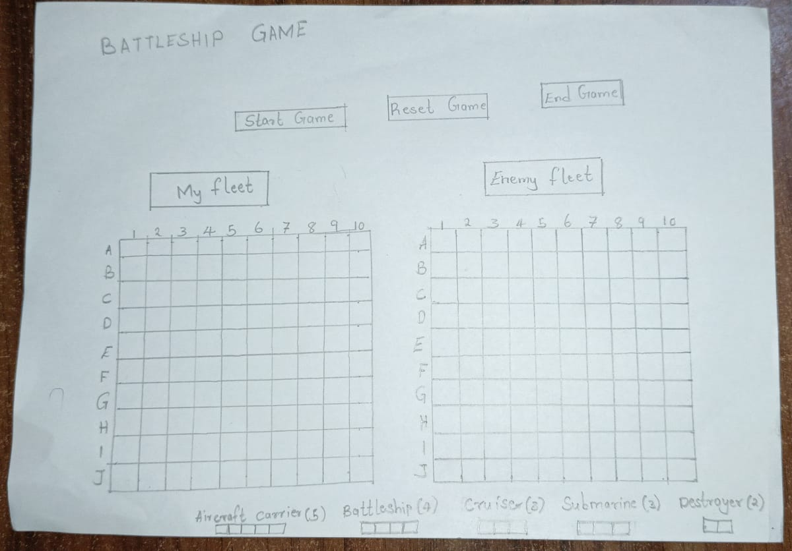

**Feedback on Battleship Game UI Design:**

**Positive Feedback:**

The design provided an organized layout which made understanding easy for users. The game interface with its player and enemy ship grids operated smoothly due to their unambiguous labeling system.

All required design components appeared in the system. Each functional component included proper placement of grids for ship set-up together with start and reset buttons and game status display. All functional requirements described in the design specifications received proper implementation.

The design arrangement featured a basic structure that offered straightforward navigation to users. All elements could be located easily while the grids occupied good positions on the interface. Reviewers found the interface design easy to follow because it clearly outlined available options each time during the game process.

Element placement maintained a steady system throughout all parts of the design. A standard position held the "Start Game" button throughout the wireframe design and all elements displayed similar visual characteristics.

The use of particular colors for grids and buttons designed an innovative system that produced enhanced visual appeal. The designers found success by using the status area to deliver instructions to users which increases their engagement.

**Constructive Criticism:**

The user interface contained small Reset Game and End Game buttons which received less visual emphasis than the Start Game button. A review team suggested enlarging the buttons for gameplay ease since they were hard to press during active sessions.

The current functional display of game status area needed to be relocated into a more dominant position. Experts believe the game status should reside at either the screen's top area or possess its own banner since they both assure better visibility.

The area where players need to place ships should be better distinguished. Placing a distinct border between the placement space and the rest of the grid received recommendation to improve the separation between both grid sections.

**Suggestions for Improvement:**

With interactive ship placement features that enable players to manipulate ships using their mouse the application would become more interactive. The interactive design would improve gameplay by letting players view their ship placement.

A multiplayer mode was suggested as a new addition to the game concepts. The system implements either dual-screen display or alternating turns which let one user place their ships until another user attempts target detection of enemy ships.

Visual and audio notifications produced during cell clicking actions should be included because these elements enhance player engagement and result in a more exciting gameplay experience.

Developers should create mobile-responsive layouts since mobile gaming is a possibility. The design will adapt various buttons along with their placement according to different screen dimensions.

**Summary of Feedback:**

The design met positive feedback because of its straightforward nature along with its complete structure. Some designers proposed adjustments for the game interface by recommending changes to the elements' dimensions and positions mainly affecting buttons and game status area. The design provides space to enable interactive elements including drag-and-drop ship placement and new gameplay components that would make user interaction more successful. I am implementing all proposed changes into the following version of the design.